**MovieGoerForm Class**

*Upon opening the application:*

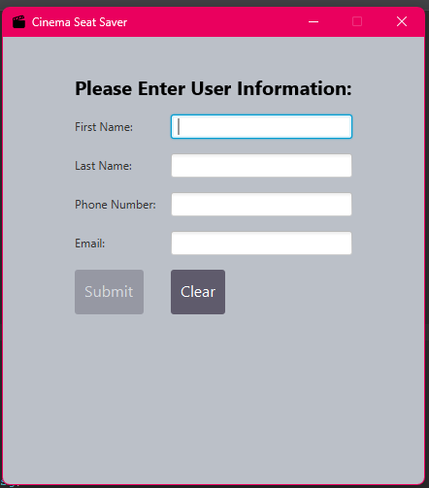

*User has input the information:*

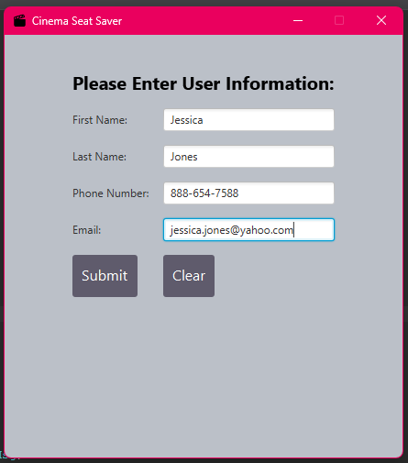

*Upon hitting the submit button:*

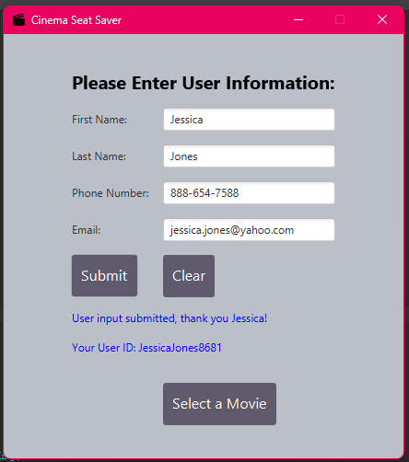

*Upon hitting the clear button:*

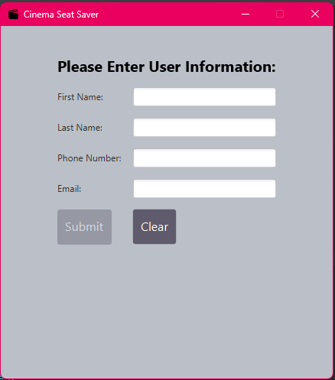

**MovieSelection Class**

*Upon opening the application:*

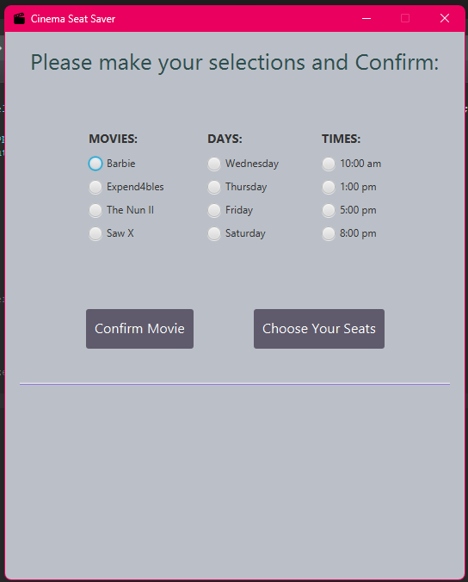

*User has input the information:*

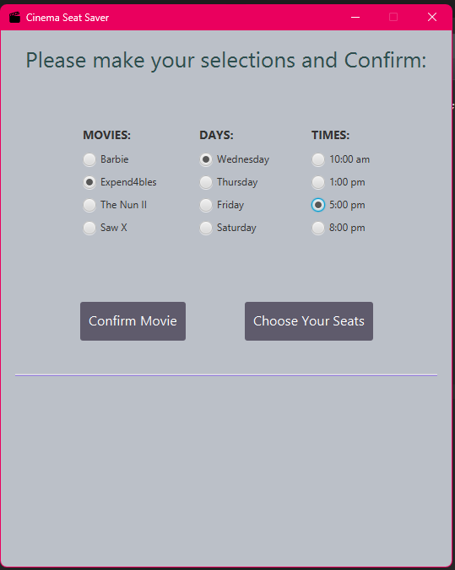

*Upon hitting the confirm button:*

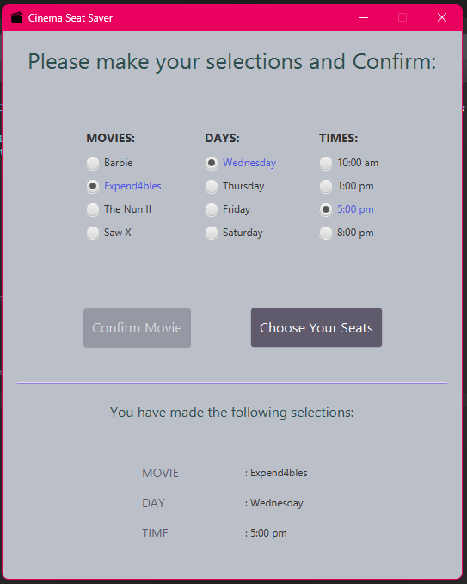

**SeatSelection Class**

*Upon opening the application:*

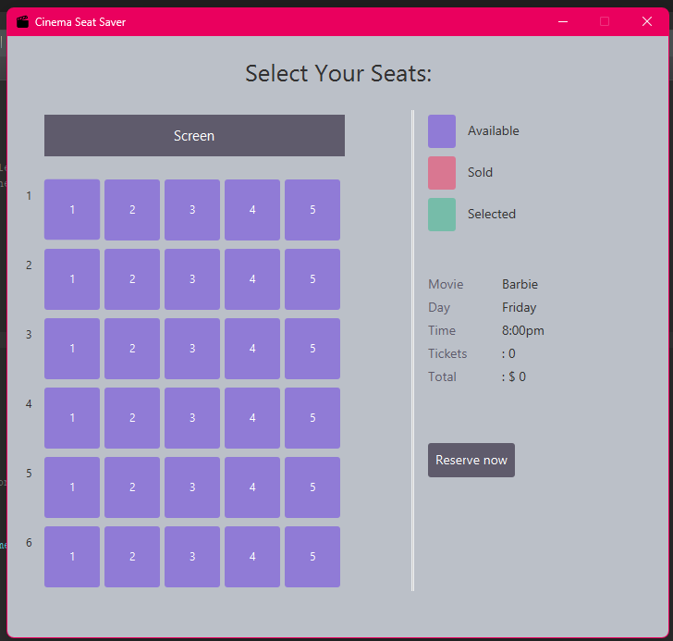

*User selects one seat:*

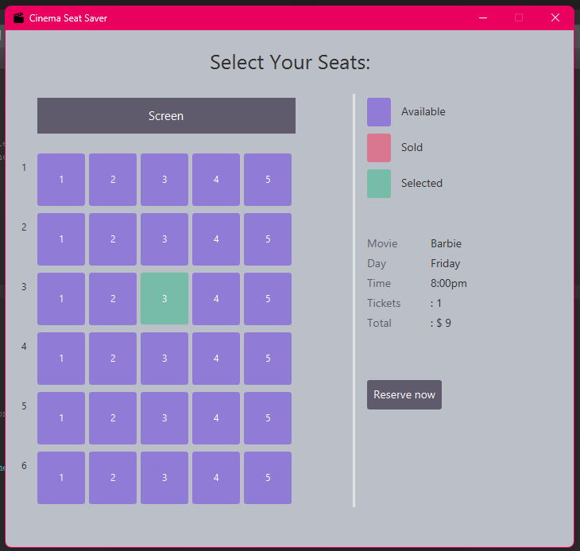

*User hits reserve button:*

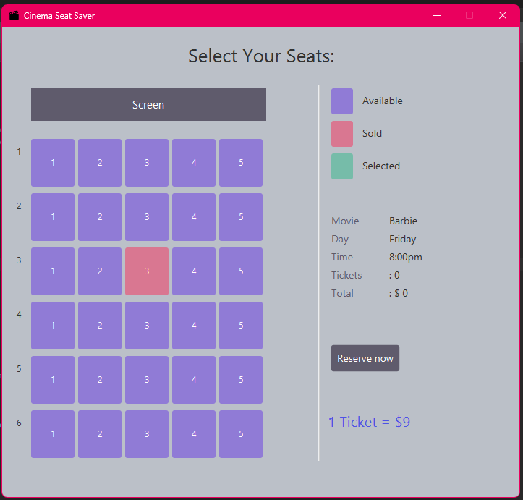

*User selects multiple seats:*

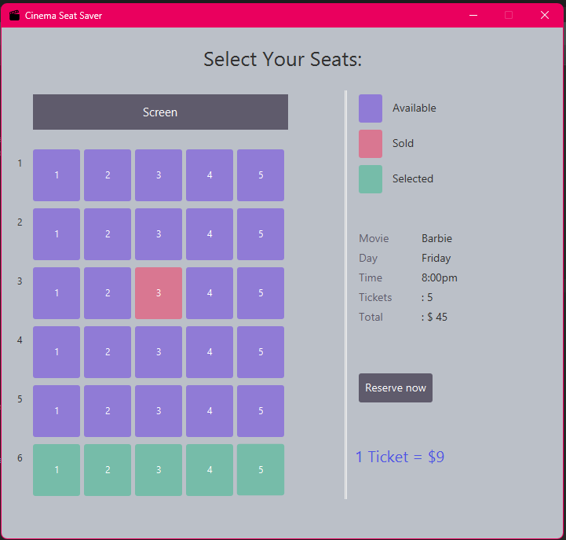

*User hits reserve button:*

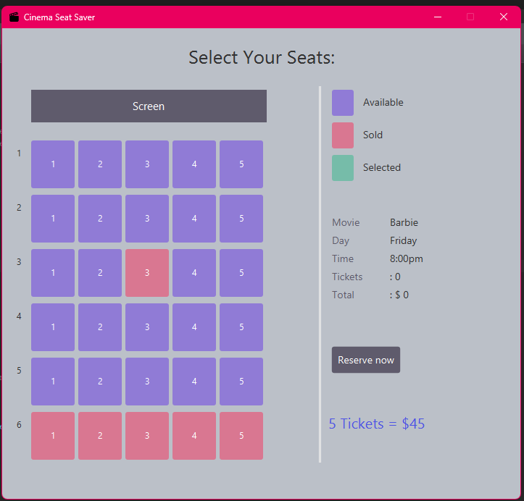

*Upon selling all the seats in the theater:*

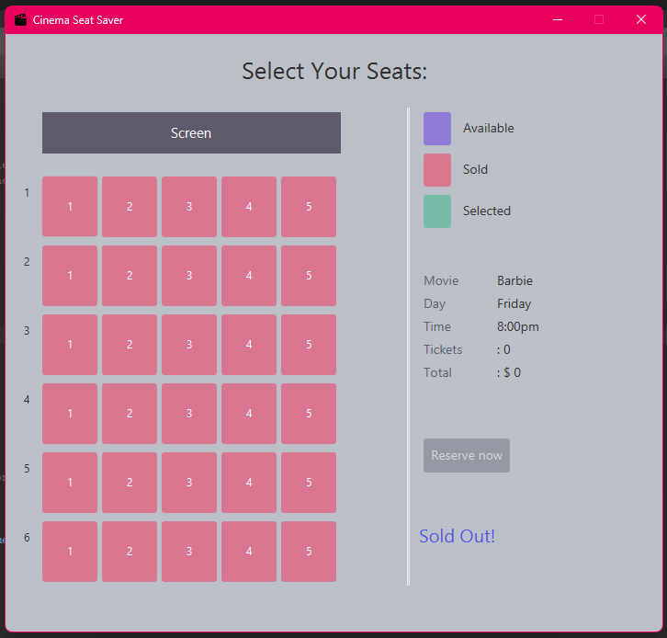

**UML Diagram**

